# Table of Contents

**Network-as-a-Service Runbook**

***Maintenance Manual Template***

**<NaaS Operator’s Name>**

**

*<Release Date>*

Table of Contents 1

1 Document Control 3

2 About Design Template 4

2.1 Document Purpose 4

3 Introduction 4

3.1 Maintenance Process 4

4 Intervention Prework 6

5 Health and Safety Measures 7

6 Maintenance Instructions 8

6.1 Corrective Maintenance 13

7 Reporting 16

# Document Control

- Revision Control sheet allows to maintain a record of changes made on the document.

|  |  |  |  |
| --- | --- | --- | --- |
| Version N° | Issue Date | Status | Reasons for Change |
|  |  |  |  |
|  |  |  |  |
|  |  |  |  |
|  |  |  |  |

Table 1. Revision History

# About this template

The purpose of this document is providing instructions and examples to elaborate a Maintenance manual, following the Cell Site Maintenance and Field work management module.

# Introduction

***Instructions:***Summarize the purpose of the Maintenance Manual.

***Example:***

***<-***The Maintenance Manual provides maintenance personnel with the information necessary to maintain the system effectively. The manual provides the roles and responsibilities of maintenance personnel, and the regular activities essential to the support and maintenance of program modules, and job streams.-**>**

## Maintenance Process

***Instructions:***Provide an overview of the Maintenance Process as will be implemented in NaaS Operations , including the charts and graphics, roles and responsibilities as necessary to depict NaaS Maintenance Organization.

***Example:***

**<-**Dispatcher and Field Technicians must follow the process described in this section to perform any Maintenance Intervention; the process is detailed in Figure A:

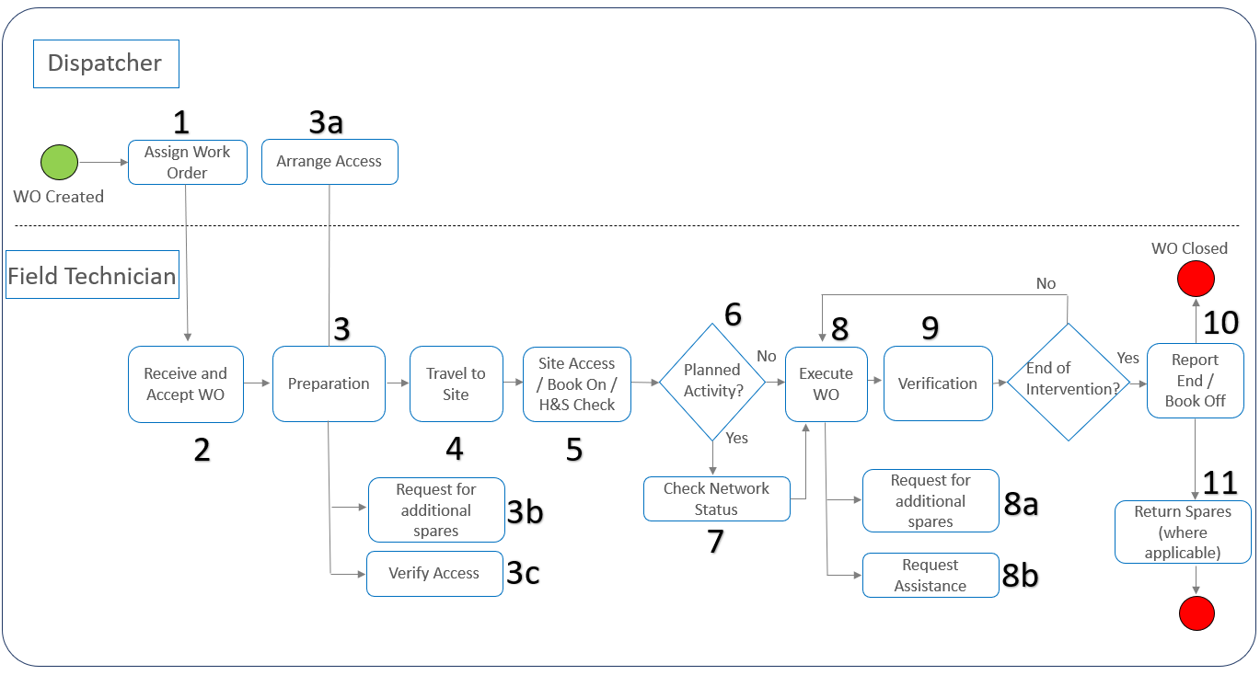

**FIGURE A. Maintenance Process**

**1.-**The main input into this process is the creation of a Work Order. Work Order creation can be initiated by one of the following processes: Incident Management, Problem Management or Change Management. If a third party (such as a fiber company) requests access to the site, the work order is processed in the same manner as the field maintenance team would have to grant access to their own team, and would supervise the work performed on-site by the third party. Work order creation can be triggered manually, but also automatically via a field dispatch tool. The dispatcher assigns the Work order to the Field Technician.

**2.-**The Field Technician receives and accepts the Work Order.

**3.-**The Field Technician then starts preparing to work on the request. As part of this preparation, the dispatcher:

**3a.-**Assures that access is granted, escalating to Access Management if needed

The Field Technician in parallel:

**3b.-**Requests for additional spares as required (which would trigger the

**3c.-**Verifies that access is granted to the site

**4.-**The Field Technician travels to the site after the preparation is done.

**5.-**Upon reaching the site the Field Technician checks for access, and for Health and Safety concerns, and books-on the site. The term “book-on” is also known as a “check-in” that is performed with the Network Operation Center to confirm the technician is on-site.

**6.-**At this point, the Field Technician checks with the NOC for any planned activity that may be scheduled. If that is the case, the information is raised to the dispatcher.

**7.-**If a planned activity is scheduled, the Field Technician checks network status with the Network Operation Center before executing the work order in order to prevent two different entities working on the site at the same time.

**8.-**If there is no planned activity in progress the Field Technician continues to execute the Work Order. During the execution of the task, the Field Technician:

**8a.-**May ask for additional spares

**8b.-**Request assistance from the Network Operation Center Tier 1 or Tier 2 level to complete the task

**9.-**After execution, the Field Technician verifies with the Network Operation Center if work has been successful. If not, the Field Technician may go back to the execution step.

**10.-**Once execution is verified successfully, the Field Technician reports the end of intervention and books-off the site. The term “book-off” is also known as a “check-out” that is performed with the Network Operation Center to confirm the technician has finished working and is ready to leave the site. After this, the work order is closed.

**11.-**Spare parts are returned, if applicable.-**>**

# Before the Maintenance Intervention

***Instructions:***Provide a full description of the preparative tasks that field technicians must perform before a departure to the site.

***Example:***

***<-1.-***Field Technicians must fill following form and provide it to Dispatcher/Field Management (*please insert the access form as previously defined in Security Procedures*):

***2.-***Field Technicians should request the required Spare Parts to the warehouse located in *insert address* indicating the work order to the warehouse personnel in turn.

***3.-***Field Technicians must ensure to gather the right tools for the Maintenance Intervention, the following tools are the minimum to consider :

1. Screwdriver Set: Knurled-Head.

2. TORX Screwdriver set: T10, T20, and T25mm.

3. Side Cutter.

4. Monkey Wrench.

5. Wrench 13mm (0.51 inch.).

6. Torque Wrench for Feeder Connectors, Battery Terminals etc.

7. Crimping Tool for 16Sq.mm to 70Sq.mm cables.

8. Hammer Drill.

9. Measuring Tape (30M).

10. Tool Case.-**>**

# Health and Safety Measures

**Instructions:** Detail the Health and safety measures including a set of tasks to prevent injuries and detail the Personal Protective Equipment that field technicians must wear before the Maintenance Intervention.

**Example:**

**<**Before any person shall commence a tower climb, they must:

1. Familiarize themselves with the risks at the Site and on the Tower and understand the risks
2. Inherent in working in an RF environment and be aware of the “go/no go” designated areas.
3. Be fully conversant with the operation of all safety equipment and techniques; and
4. Take into consideration current and predicted weather conditions and take the requisite Winds higher than 30 km / h, ice formation and/or snow accumulation, its required to suspend work at height, except critical areas, where works must have an authorization explicitly by engineering and must be informed the chief of operations before implementation
5. Precautions to prevent exposure and potential slip hazards.

During the climb each person must:

**a)**Limit their work on the Tower solely to the area and work approved on the Tower Access

**b)**Carry a means of portable communications,

**c)**Verify the presence of fire extinguisher and first aid Kit

**3.1 Personal Protective Equipment:**

All NaaS Operator Field Workers that will work in tower site must wear their PPE this requisite is mandatory :

|  |  |  |
| --- | --- | --- |
| Panoramic eye protectors |  |  |
| Helmet with chinstrap for work at height |  |  |
| Dielectric safety footwear |  |  |
| High abrasion gloves |  | Abrasion Resistant Work Gloves | Aviation Spares & Repairs |
| Dielectric gloves |  |  |
| Full body safety harness |  |  |
| Double lashing strap (monkey tail) |  |  |

**>**

# Work Order Execution

***Instructions:*** Introduce the set of tasks to be performed by the field technician in any type of maintenance intervention, which could be preventive or corrective. The recommended structure is detailed as follows:

1. **Preventive Maintenance Instructions**
   1. Antenna System
   2. Baseband and Transmission System
   3. Power System
   4. Facilities
2. **Corrective Maintenance Instructions**
   1. Antenna System
   2. Baseband and Transmission System
   3. Power System
   4. Facilities

## Preventive Maintenance Instructions

***Instructions:*** The preventive maintenance instructions should be detailed step-by-step in the Maintenance Manual as clearly as possible, including photos of the equipment in the expected standard reference conditions and instructions to perform a service if required (for more information please see the Cell site maintenance module).

**Example:**

Field Technicians must inspect the RAN sites and perform a regular service as follows:

**<Antenna System Preventive Maintenance Procedure:**

**1.-** Check Radio Units caps and seals of unused ports, replace the caps and seals if it’s required. Figure 1 shows the cap replacement of a Radio Unit:

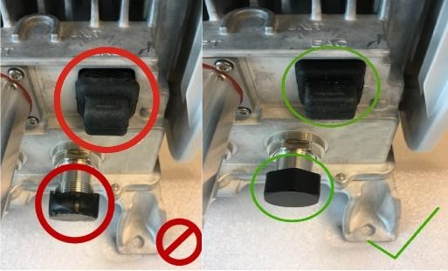

*Figure 1 Caps and Seals Replacement in a Radio Unit*

**2.-** In case RF ports are isolated by insulation tape, check the overall condition of the isolation in the antenna and the radio side, and determine if it is required to remove old rubber and apply new isolation to the ports, perform the same procedure to the Power port in the Radio Unit. *Figure 2* shows the RF port isolations of a 4X4 MIMO configuration.

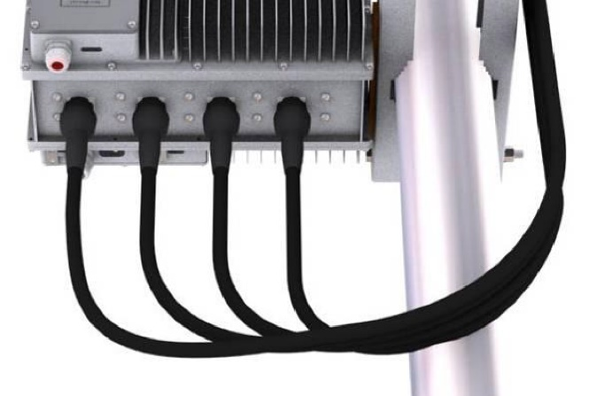

*Figure 2 RF Ports seals in good conditions*

**3.-**Check the Radio Unit mounting fixing screw tightness. Tight all the loose screws to the torque value specified in the respective product installation manual and replace any damaged screw. *Figure 3* indicates the fixing screws of a radio unit mounting kit.

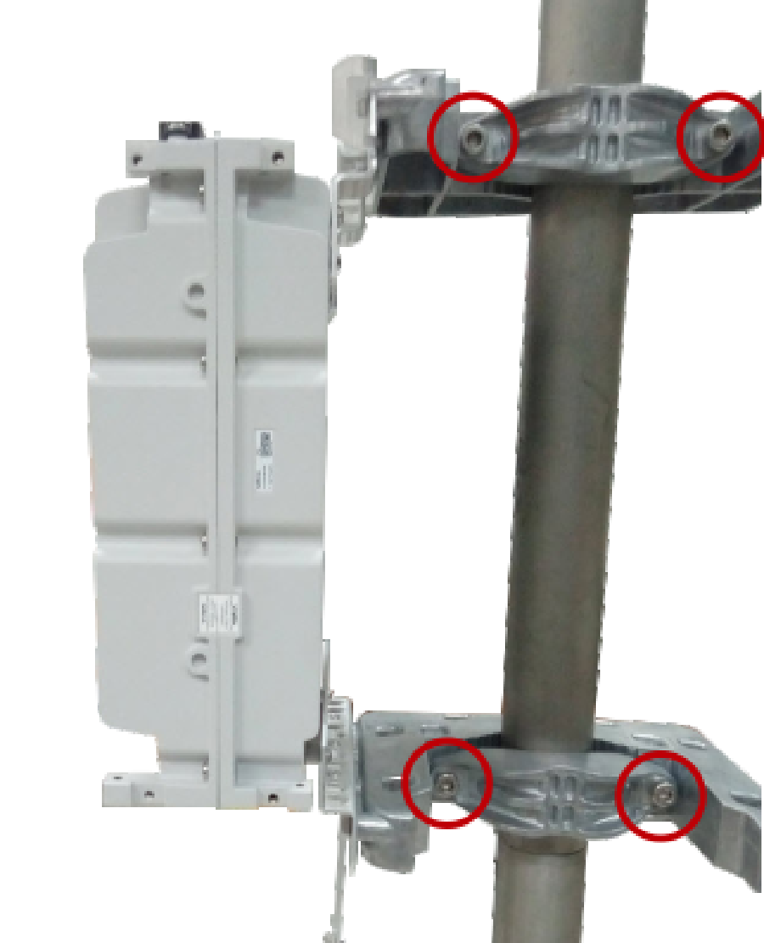

*Figure 3 Radio Unit Mounting Fixing screws*

**4.-**Check the fixing screws of the antenna mounting, the mechanical tilt and azimuth must be verified and compared with the site documentation, in case of mismatch readjust the Mechanical Tilt and Azimuth as indicated by the antenna installation procedures. *Figure 4* shows the elements that should be verified during the antenna inspection.

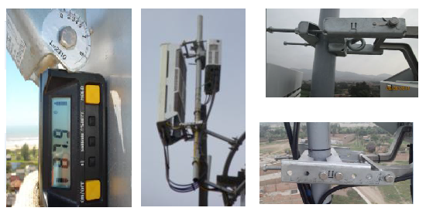

*Figure 4 Antenna Mounting Verification*

**5.-**If Microwave transmission is used, check the IF cable and/or Power Cable isolation in case of an All Outdoor Configuration. *Figure 5* shows the isolation of the IF cable and the Power Cable.

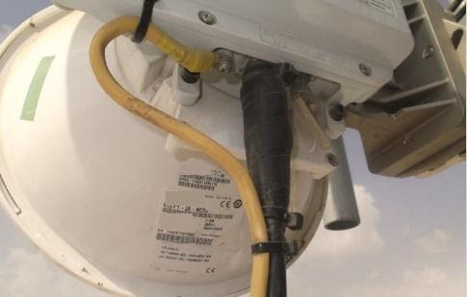

*Figure 5 Seals on a Microwave connections*

**Baseband and Transmission System Preventive Maintenance Procedure:**

**1.-**Ensure the fan units are clear of objects, in case of the presence of dust in the fan outlets it must be cleaned. The figure below shows the air outlet of an indoor Baseband in optimal conditions. *Figure 6* shows the fan outlets of a radio baseband.

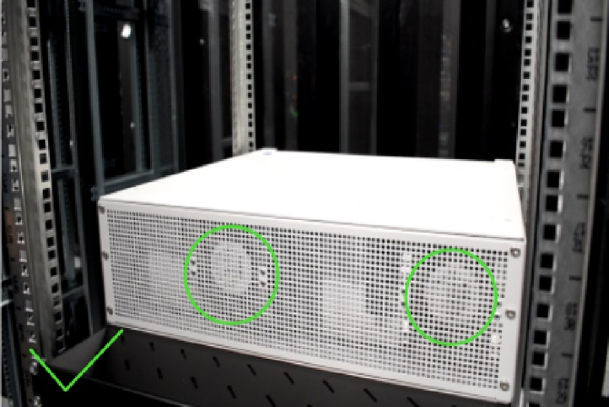

*Figure 6 Baseband's clean fan outlets*

**2.-**Check the Isolation of the cabinet or shelter, especially in cable entrance, check the isolation of the cable entrance. There is no presence of water inside the cabinet or shelter, in case is detected water corrective actions must be performed as soon as possible. *Figure 7* shows the cable entrance of a cabinet properly isolated.

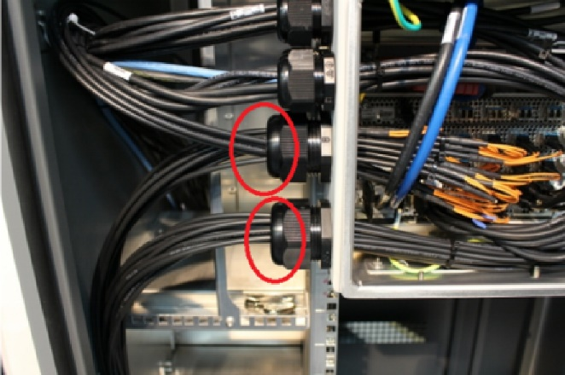

*Figure 7 Cable entrance of an IP65 Cabinet*

**3.-**Checkthe Overall Condition of the cabinet, look for dents, cracks, holes, or corrosion on the surface of the cabinet and whether the lock is normal, and the door can be opened and closed easily. *Figure 8* shows an IP65 cabinet in good condition.

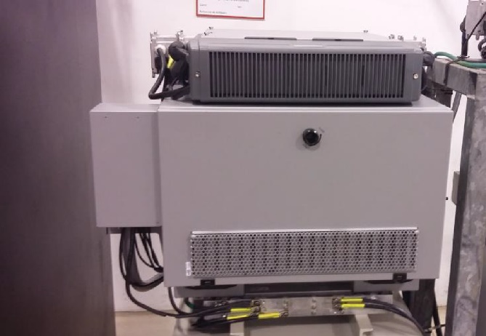

*Figure 8 Baseband Cabinet in good conditions*

**4.-** Perform an alarm validation of the site, all baseband and transmission equipment include LEDs that indicate abnormal status, validate with NOC and check locally the alarms and clear them if it’s possible. *Figure 9* shows the alarm indicators of a baseband board.

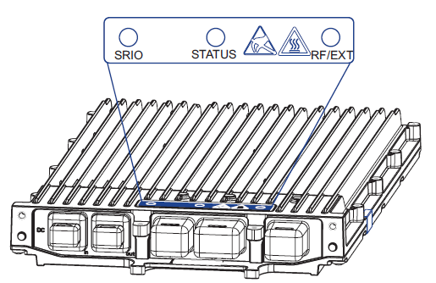

*Figure 9 LED indicators of a baseband board*

**Power System: Electric Installation, Rectifiers and Batteries.**

**1.-** Checkthe connections of power cables, the power cables are not aging, and there is no corrosion on the connection points. *Figure 10* shows an Outdoor Power Distribution Unit Connection in good conditions:

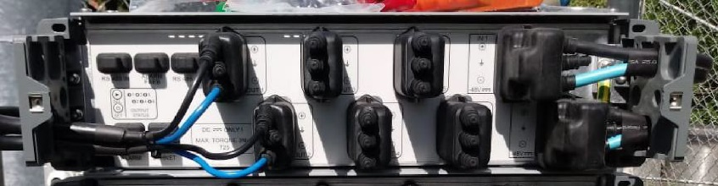

*Figure 10 Power connections properly isolated*

**2.-** The rectifiers input voltage should not exceed their operative voltage, and their output must not exceed the operative voltage of the system, in case Field Technicians detect voltage variations corrective actions must be scheduled with the Dispatcher/ Field Management. *Figure 11* shows the input power measurement using a multimeter.

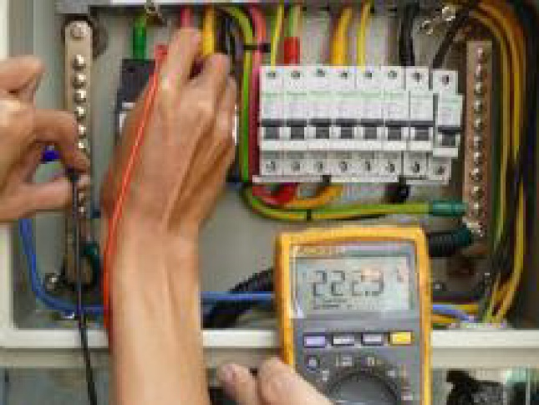

*Figure 11 Input power measurement*

**3.-** Checkthe GND cable and grounding bar. Ensure that the connections of the GND cables are solid with no corrosion on them. *Figure 12* shows the grounding connections of a cabinet.

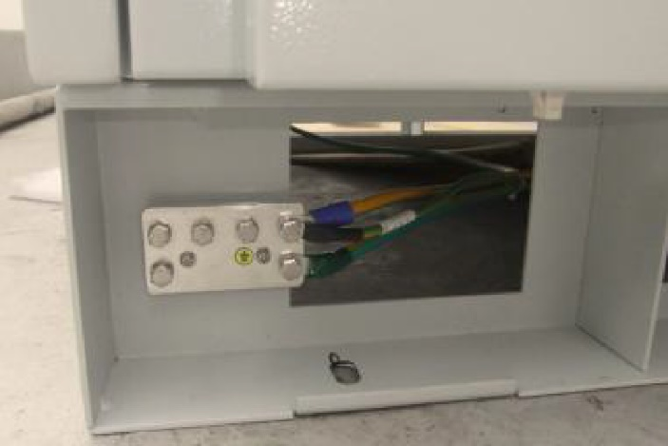

*Figure 12* *Grounding Connections in good conditions*

**4.-**The batteries must be verified including the connections conditions and the battery capacity, which measurements must be within the normal range. *Figure 13* shows a battery array in good conditions.

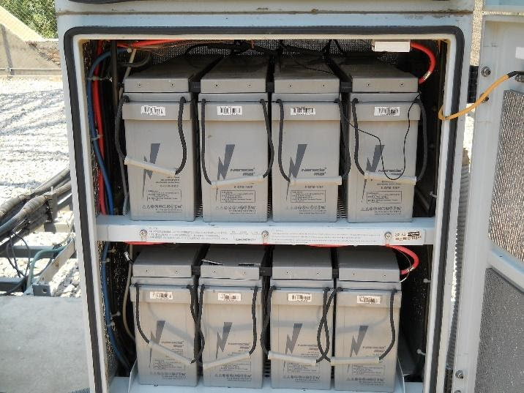

*Figure 13 Battery connections in good conditions*

**5.-**The overall condition of the facilities must be inspected by the Field supervisors ensuring that the fences, tower, ladders, shelters in case there is one in the site, remain clean without corrosion and in good conditions, in case Field technicians note a degradation of the facilities they may perform the actions that don’t affect the service such as painting or sealing with non-invasive products like sealant paste. If field technicians note that is required any corrective actions beyond of what they might perform then the Dispatcher/ Field Management must be notified.

**Closing Activities**

**Fill and sign the Maintenance Checklist:**

***Insert the Maintenance Checklist file as is defined in Cell site Maintenance Module>***

## Corrective Maintenance

***Instructions:*** This section must include the set of tasks to be performed by the field technician in case corrective actions are required. This must contain guidance to prevent more problems during any corrective intervention, including replacement instructions of the hardware elements of the cell sites such as antennas, radios, transmission equipment, baseband boards, power system and cables as is indicated in the vendor documentation

**<Baseband Corrective Maintenance**

**Pre-requisites**

•Electrostatic Discharge (ESD) can damage the baseband boards. Field Technicians must wear an ESD wrist strap or use a corresponding method when handling the baseband boards.

•Field technicians must ensure that there is a backup configuration file of the baseband and transmission configuration, they must call the NOC to ensure such file is available and contain the last backup file.

**Procedure:**

**1.-**Check if Baseband and Transmission breakers are turnedon and have no damage. In case it is switched off, turn on the switch which should remain on. In the case of automatically switch off, do not turn it on again.

**2.-**Check cable connection between transmission equipment and baseband. Replace the cable if necessary.

**3.-**Check the baseband transmission status from the local maintenance port this process should be detailed in vendor documentation. In case transmission is not available Field Technician must notify the NOC.

**4.-**Check if the Power Cables are properly connected to the baseband and transmission equipment, and connectors are not burned. The Power cable should not have any presence of damage. Replace the connectors or cable if it is necessary.

**5.-**If power cables and breakers are in good condition, measure the voltage output from the PDU, which should be within the operative voltage, replace rectifiers in case voltage are not within the operative voltage ranges

If PDUs and rectifiers are working properly a board replacement should be considered.

**Board Replacement:**

**1.-** Disconnect the DC mains power breaker.

**2.-** Disconnect the cables keeping a connection map that shows the connections.

**3.-** Unscrew the two baseband board screws as is indicated in *Figure 14*:

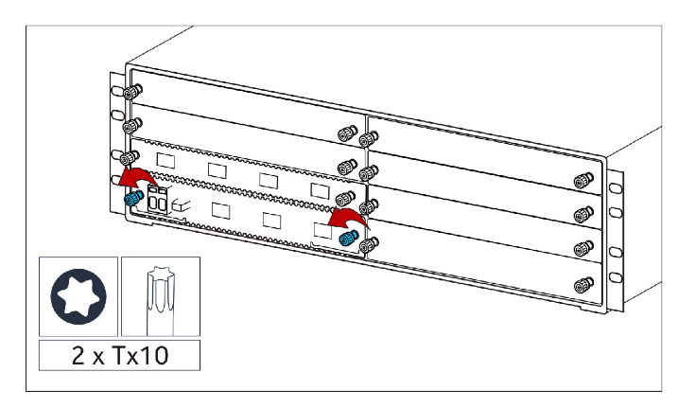

*Figure 14* *Unscrew baseband board*

**4.-**Open the two baseband board extractors as is indicated in *Figure 15*.

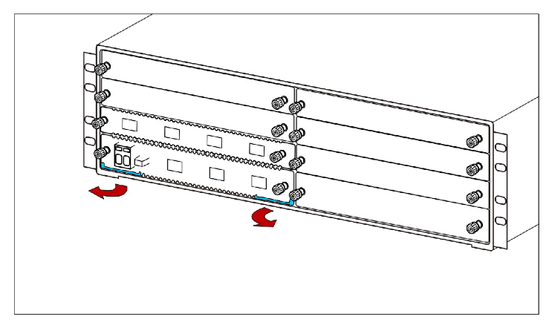

*Figure 15 Opening the board extractors*

**5.-** Pull out the baseband board from the chassis as is indicated in *Figure 16*.

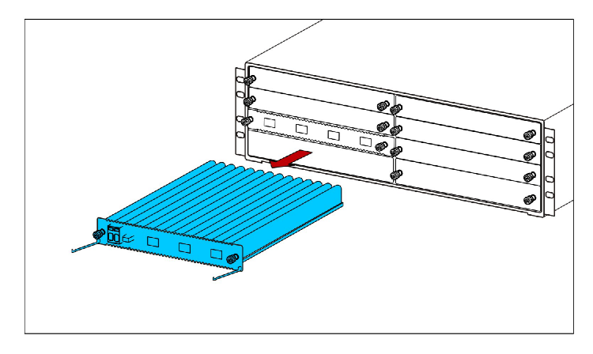

*Figure 16* *Pulling out a baseband board*

**6.-**Open the extractors in the new baseband board.

**7.-** Insert the new common baseband board carefully into the chassis and close the extractors as is indicated in *Figure 17*.

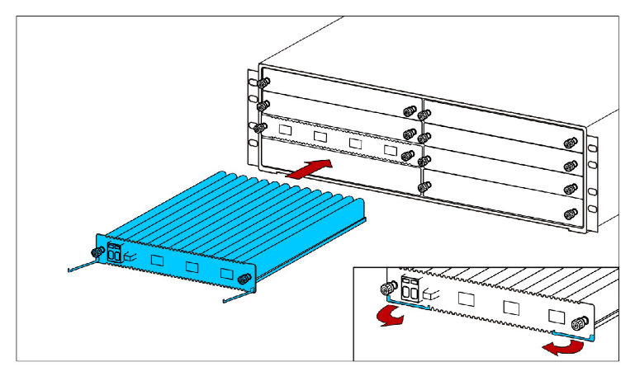

*Figure 17 Inserting a baseband board*

**8.-**Tighten the two screws by hand, and then tighten them to 1 Nm, using a TX10 screwdriver as is indicated in *Figure 18*.

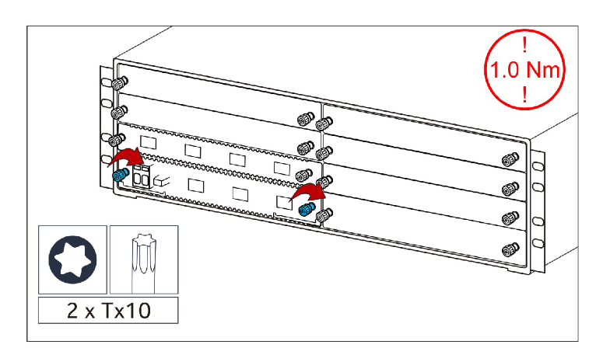

*Figure 18Tighting the screws of a baseband board*

**9.-**Cable the baseband board as it was cabled before the replacement. The same cables must be connected to the same ports. Remember also about clamping the DC cables and the GND cables.

**10.-**Load a backup commissioning file the Local Maintenance Console after plugging in the module.

**Closing Activities**

Field Technician must verify with the NOC if there are more alarms, clear all of them and create a final backup-commissioning file. ***>***

# Maintenance Intervention Report

***Instructions:*** This section must detail the reporting process that NaaS Operators has defined ,please see the module Field work management for more detail.

***Example:***

**<1.-**Field technicians must fill the following file: *insert a maintenance report template* , sign it and upload it to: *https://naasopdrivesite.com/maintenance_interventions***>**